Bachelor of Technology

PROJECT REPORT OF INDUSTRIAL TRAINING

ON

CORE JAVA WITH PROJECT- **QUIZ APP**

Department of Computer Science

COLLEGE NAME

SUBMITTED TO: SUBMITTED BY:

TEACHER NAME YOUR NAME

(DEPT. OF COMPUTER SC.) ROLLNO

# ACKNOWLEDGEMENT

I feel great pleasure to acknowledge all those involved in the process of my education and research. In the first place I would like to record our deep and sincere gratitude to my training incharge, TEACHER NAME mam for her supervision, advice, guidance, and crucial contribution, which made her a backbone of this project. Her understanding, encouraging and personal guidance have provided a good basis for the present project. Her involvement with her originality has triggered and nourished our intellectual maturity that I will benefit from, for a long time to come. I wish to express our gratitude towards our all teachers, who helped us throughout our course work. I extend our acknowledgement to our lab mates, lab staff, who are directly or indirectly involved in carrying out the project work.

Place: YOUR NAME

(ROLL NO)

# 

**INDEX**

|  |  |
| --- | --- |
| 1. | **Introduction** |
|  | (i) Statement about the problem- Existing system |
|  | (ii) Objectives of Project |
|  | (iii) Working Environment |
| 2. | **System Design** |
|  | (i) Data Flow Diagram |
|  | (ii) Database Files |
|  | (iii) Relations in the Databases |
|  | (iv) Screen Shots |
| 3. | **Conclusion** |
| 4. | **Bibliography** |

1. INTRODUCTION:

This is a project on Quiz App, developed using JAVA programming language. This Quiz App is a classic Desktop Application. The objective of this Quiz App is to conduct of the users that are registered on the application. There are various types of quizzes available in the Quiz App that a user can give. It has separate work spaces for Users and the Admin. The Admin can control the application activity around the screen.

The main objective of this project is to give a brief understanding of JAVA programming language and the technical guidance that how various Open source developer tools works!

Technology used in this project is JAVA Swings. This game is written in JAVA using java NetBeans IDE software. Java is a programming language and a platform. It is a high level, robust, object-oriented and secure programming language. It is used to develop mobile apps, web apps, desktop apps, games and much more.

JAVA Swing is a part of Java Foundation Classes (JFC) that is used to create window-based applications. It is built on the top of AWT (Abstract Windowing Toolkit) API and entirely written in java. Unlike AWT, Java Swing provides platform-independent and lightweight components. The javax.swing package provides classes for java swing API such as JButton, JTextField, JTextArea, JRadioButton, JCheckbox, JMenu, JColorChooser etc.

In the end page i.e. in bibliography links to the resources are given from which the information used in this project is taken.

**(I) Statement about the Problem-existing system**

Experts agree that the most valuable asset and only true competitive advantage of any organization are the people on its team. Having the right people in the right jobs can make the difference between industry leadership and mediocrity, between loyal customers and shrinking market share, and between project success and failure. That's why Quiz is dedicated to helping organizations use assessment science to predict employee success. Using the Quiz assessment platform, companies improve hiring and retention, boost training success, enhance customer satisfaction, and increase profitability.

**(II) Objectives of Project**

After thoroughly analysing the existing system the following objectives have been set:

* With Quiz as part of the screening process, employers can use their time more efficiently plus retain data that gives more accuracy and defensibility to their hiring decisions.
* All Quiz testing is Web-based and can be administered through email, through the Skill Rating website, private labelled, or at an in-office computer.
* For employees that need quick on the job training, our skills assessment tests can be used as training tools to focus on career management skills that need improvement. Testing scores along with detailed answer solutions can be emailed directly to the candidate.
* The website is easy to use and understand by anyone.
* There is no specific web browser that you must have or install before using.

The main objective of this project is to give a detailed understanding of JAVA programming language and the technical guidance that how various Open source developer tools works. In this project Swing part of java is used, which is a part of Java Foundation Classes (JFC) that is used to create window-based applications. This project also helps in understanding the advance concept of Window Application Development using JAVA Swing.

**(III) WORKING ENVIRONMENT**

**Hardware requirements:**

In hardware requirement we require all those components which will provide us the platform for the development of the project. The minimum hardware required for the development of this project is as follows—

* RAM- minimum 128 MB
* Hard disk- minimum 5 GB
* Processor- Pentium 4 and above
* Floppy drive and CD drive

These all are the minimum hardware requirement required for our project. We want to make our project to be used in any type of computer therefore we have taken minimum configuration to a large extent.128 MB ram is used so that we can execute our project in a least possible RAM.5 GB hard disk is used because project takes less space to be executed or stored. Therefore, minimum hard disk is used. Others enhancements are according to the needs.

**Software requirements**:

Software’s can be defined as programs which run on our computer. It acts as petrol in the vehicle. It provides the relationship between the human and a computer. It is very important to run software to function the computer. Various Software’s are needed in this project for its development. Which are as follows:

Operating System- Windows 10.

Developing Interface- Netbeans IDE 7.2

Others- Visual Studio

We will be using visual basic as our front hand because it is easier to use and provides features to the users which is used for the development of the project.

**Software Requirement Analysis**

**JAVA:**

Java is an object-oriented programming language developed by Sun Microsystems, a company best known for its high-end UNIX workstations. Modeled after C++, the Java language was designed to be small, simple, and portable across platforms and operating systems. It is intended to let application developers "write once, run anywhere" (WORA), meaning that code that runs on one platform does not need to be recompiled to run on another. Java applications are typically compiled to byte-code (class file) that can run on any Java virtual machine (JVM) regardless of computer architecture. Java was originally developed by James Gosling at Sun Microsystems(which has since merged into Oracle Corporation) and released in 1995 as a core component of Sun Microsystems' Java platform. The language derives much of its syntax from C and C++, but it has fewer low-level facilities than either of them.

**Characteristics of Java**

The target of Java is to write a program once and then run this program on multiple operating systems.

Java has the following properties:

* **Platform independent:** Java programs use the Java virtual machine as abstraction and do not access the operating system directly. This makes Java programs highly portable. A Java program (which is standard complaint and follows certain rules) can run unmodified on all supported platforms, e.g. Windows or Linux.
* **Object-orientated programming language:** Except the primitive data types, all elements in Java are objects.
* **Strongly-typed programming language:** Java is strongly-typed, e.g. the types of the used variables must be pre-defined and conversion to other objects is relatively strict, e.g. must be done in most cases by the programmer.
* **Interpreted and compiled language:** Java source code is transferred into the bytecode format which does not depend on the target platform. These bytecode instructions will be interpreted by the Java Virtual machine (JVM). The JVM contains a so called Hotspot-Compiler which translates performance critical bytecode instructions into native code instructions.
* **Automatic memory management:** Java manages the memory allocation and de-allocation for creating new objects. The program does not have direct access to the memory. The so-called garbage collector deletes automatically objects to which no active pointer exists.

**Java Virtual machine**

The Java virtual machine (JVM) is a software implementation of a computer that executes programs like a real machine. The Java virtual machine is written specifically for a specific operating system, e.g. for Linux a special implementation is required as well as for Windows. Java programs are compiled by the Java compiler into byte-code. The Java virtual machine interprets this byte-code and executes the Java program.

**Java Runtime Environment vs. Java Development Kit**

A Java distribution comes typically in two flavours, the Java Runtime Environment (JRE) and the Java Development Kit (JDK). The Java runtime environment (JRE) consists of the JVM and the Java class libraries and contains the necessary functionality to start Java programs. The JDK contains in addition the development tools necessary to create Java programs. The JDK consists therefore of a Java compiler, the Java virtual machine, and the Java class libraries.

**My SQL :**

MySQL is currently the most popular open source database server in existence. On top of that, it is very commonly used in conjunction with PHP scripts to create powerful and dynamic server-side applications. MySQL is a fast, easy-to-use RDBMS being used for many small and big businesses. MySQL is developed, marketed, and supported by MySQL AB, which is a Swedish company. MySQL is becoming so popular because of many good reasons:

* MySQL is released under an open-source license. So you have nothing to pay to use it.
* MySQL is a very powerful program in its own right. It handles a large subset of the functionality of the most expensive and powerful database packages.
* MySQL uses a standard form of the well-known SQL data language.
* MySQL works on many operating systems and with many languages including PHP, PERL, C, C++, JAVA, etc.
* MySQL works very quickly and works well even with large data sets.
* MySQL is very friendly to PHP, the most appreciated language for web development.
* MySQL supports large databases, up to 50 million rows or more in a table. The default file size limit for a table is 4GB, but you can increase this (if your operating system can handle it) to a theoretical limit of 8 million terabytes (TB).
* MySQL is customizable. The open-source GPL license allows programmers to modify the MySQL software to fit their own specific environments.

**Features of MY SQL :**

* **Scalability and Flexibility:** The MySQL database server provides the ultimate in scalability, sporting the capacity to handle deeply embedded applications with a footprint of only 1MB to running massive data warehouses holding terabytes of information.
* **High Performance:** A unique storage-engine architecture allows database professionals to configure the MySQL database server specifically for particular applications, with the end result being amazing performance results. Whether the intended application is a high-speed transactional processing system or a high-volume web site that services a billion queries a day, MySQL can meet the most demanding performance expectations of any system.
* **Robust Transactional Support:** MySQL offers one of the most powerful transactional database engines on the market. Features include complete ACID (atomic, consistent, isolated, durable) transaction support, unlimited row-level locking, distributed transaction capability, and multi-version transaction support where readers never block writers and vice-versa.
* **Web and Data Warehouse Strengths:** MySQL is the de-facto standard for high-traffic web sites because of its high-performance query engine, tremendously fast data inserts capability, and strong support for specialized web functions like fast full text searches. These same strengths also apply to data warehousing environments where MySQL scales up into the terabyte range for either single servers or scale-out architectures.
* **Comprehensive Application Development:** One of the reasons MySQL is the world's most popular open source database is that it provides comprehensive support for every application development need. Within the database, support can be found for stored procedures, triggers, functions, views, cursors, ANSI-standard SQL, and more.
* **Open Source Freedom and 24 x 7 Support:** Many corporations are hesitant to fully commit to open source software because they believe they can't get the type of support or professional service safety nets they currently rely on with proprietary software to ensure the overall success of their key applications. The questions of indemnification come up often as well. These worries can be put to rest with MySQL as complete around-the-clock support as well as indemnification is available through MySQL Network.

2. DESIGN OF PROJECT:

System design is the process of developing specifications for a candidate system that meet the criteria established in the system analysis. The plan of the project provides a review of the different modules in which the project is divided. The modules are designed and tested individually and then merged together to form an integrated project. The different tables being used are:

|  |
| --- |
| **Tables** |
| * + 1. Answer     2. Questions     3. Registration     4. City     5. result     6. Technology |

Table Database

The various roles through which the data flows used in the project are:

1. **Administrator**
2. **User**

**(I) DATA FLOW DIAGRAM**

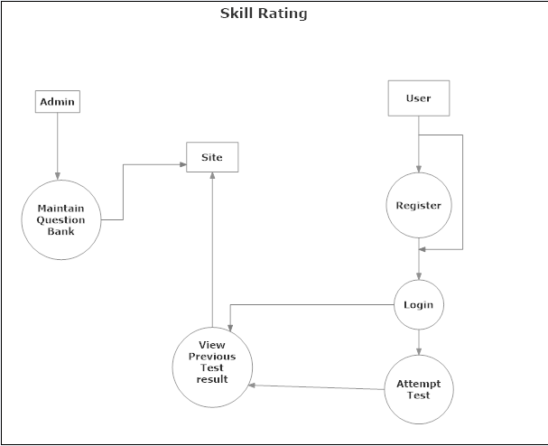

**(II) DATABASE FILES**

|  |  |  |
| --- | --- | --- |
| Sr. No. | Table Name | Description |
| 1. | Tbans | Answers for questions. |
| 2. | Tbqst | Information about Question. |
| 3. | Tbreg | Information about Registration. |
| 4. | Tbres | Information about questions result. |
| 5. | Tbtec | Information about the question technology. |

**(III) RELATIONS IN THE DATABASE FOR QUIZ**

The following are the relations we have designed to manage the database. Here we have followed a convention of having the table names with tb as a prefix, and the remaining name of the table represent the description of the data inside that table.

**Tbreg(Registration)**

|  |  |  |  |
| --- | --- | --- | --- |
| Regcod | int | PK | Registration code. |
| Regeml | varchar(50) | Not Null | Registration email. |
| Regpwd | varchar(50) | Not Null | Registration password. |
| Regdat | datetime | Not Null | Registration date. |

**Tbans (Answer)**

|  |  |  |  |
| --- | --- | --- | --- |
| Anscod | int | PK | Code |
| Ansqstcod | int | FK | Code |
| Ansdsc | varchar(1000) | Not Null | Description |
| Anssts | char(1) | Not Null | Status |

**Tbqst(Questions)**

|  |  |  |  |
| --- | --- | --- | --- |
| Qstcod | int | PK | Code |
| Qstteccod | int | FK | Tec. Code |
| Qsttit | varchar(500) | FK | Title |
| Qstpic | varchar(50) | Not Null | Picture |

**Tbres(Result)**

|  |  |  |  |
| --- | --- | --- | --- |
| Rescod | int | PK | Code |
| Resdat | datetime | Not Null | date |
| Resteccod | int | FK | Code |
| Resdur | float | Not Null | Duration |
| Resscr | int | Not Null | Score |

**Tbtec(Technology)**

|  |  |  |  |
| --- | --- | --- | --- |
| Teccod | Int | PK | Code |
| Tecnam | varchar(100) | Not Null | Name |

**(V) SCREENSHOTS**

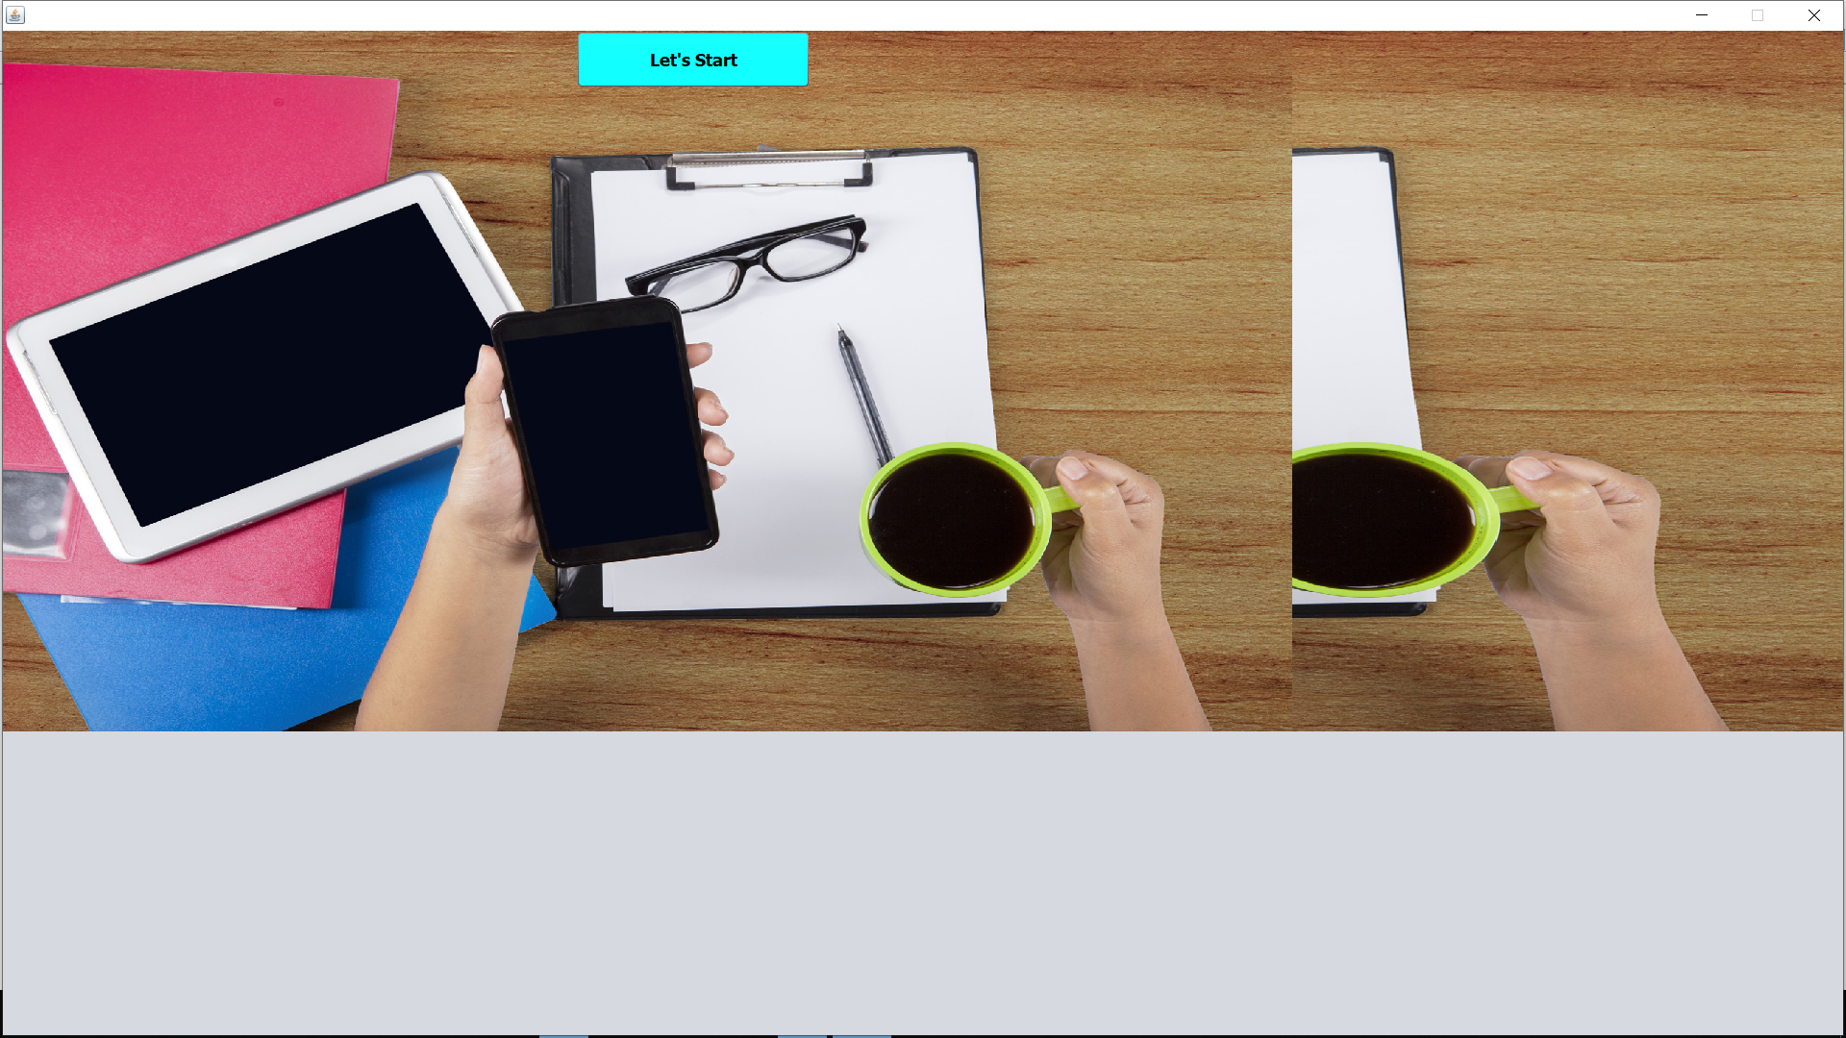

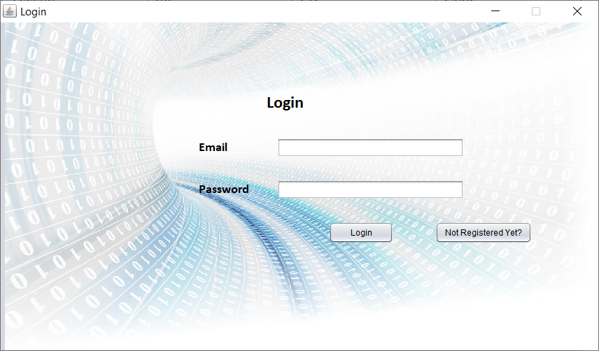



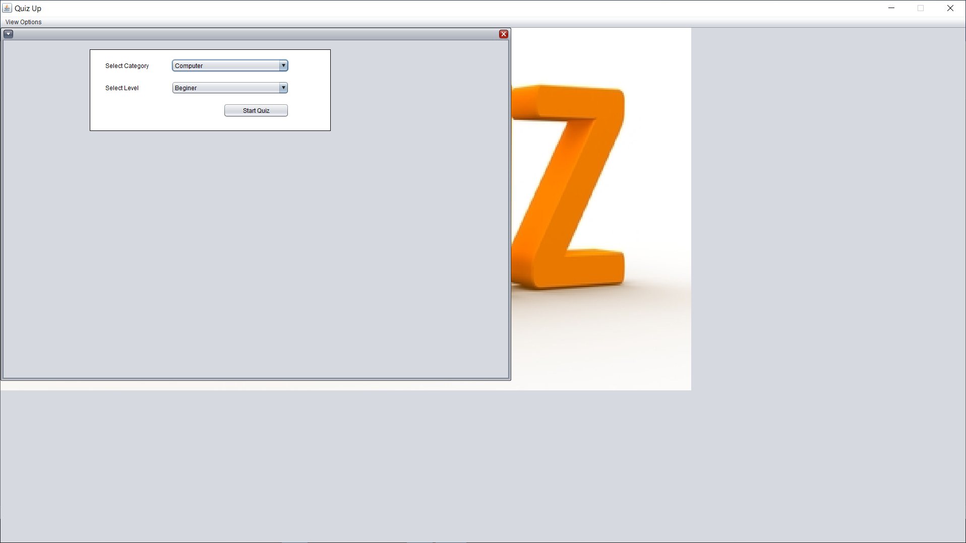

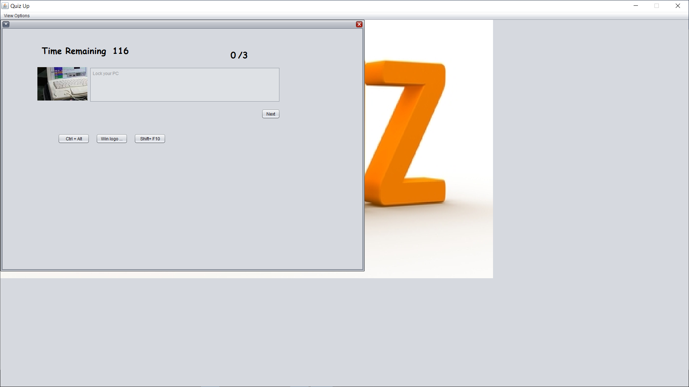

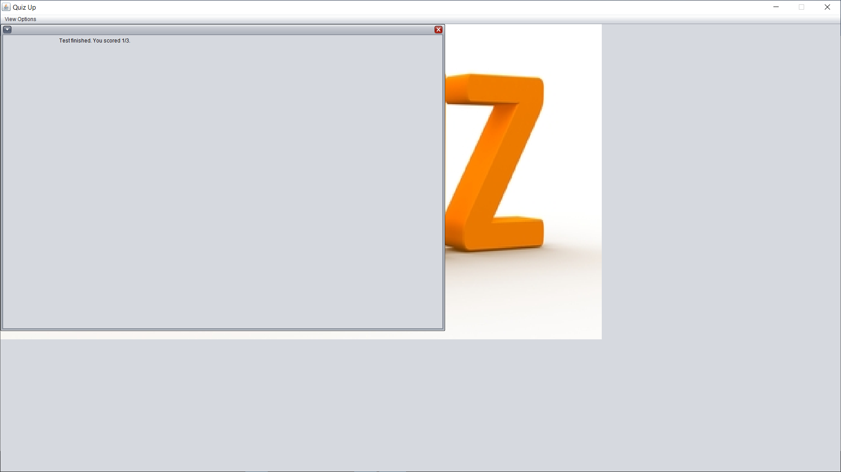

3. CONCLUSION:

The system has been developed for the given condition and is found working effectively. The developed system is flexible and changes can be made easily whenever required. Using the facilities and functionalities of JAVA, the software has been developed in a neat and simple manner, thereby reducing the operator’s work.

The speed and accuracy are maintained in proper way. The user-friendly nature of this software developed in JAVA and Java Swings is very easy to work with both the higher management as well as other users with little knowledge of computer. The results obtained were fully satisfactory from the user point of view.

The system was verified with valid as well as invalid data in each manner. The system is run with an insight into the necessary modifications that may be required in the future. Hence the system can be maintained successfully.

4. BIBLIOGRAPHY:

**CATALOGUES**

Training sessions conducted by company itself.

**BOOKS**

Database management system Vipin C. Desai

System Analysis and Design Elias M. Awad

SQL Server Microsoft Press

ASP.NET Wrox publications

Java Herbert Schildt

**WEBSITES**

* www.google.com
* www.wikipedia.org
* www.w3schools.com
* www.geeksforgeeks.org
* www.tutorialspoint.com